|  |  |
| --- | --- |
| **Ex.No : 8** | **Implementation of Storage as a Service** |
| **09.05.2022** |

**Aim:**

To implement Storage as a Service using AWS S3.

**Procedure:**

**Step 1:** Go to AWS dashboard and search for S3 services.

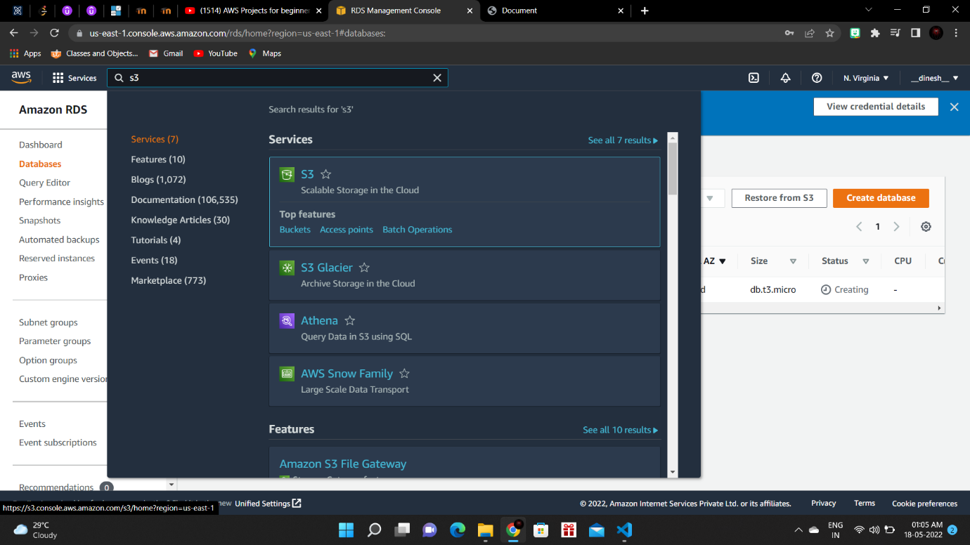

**Step 2:** Create a new Bucket.

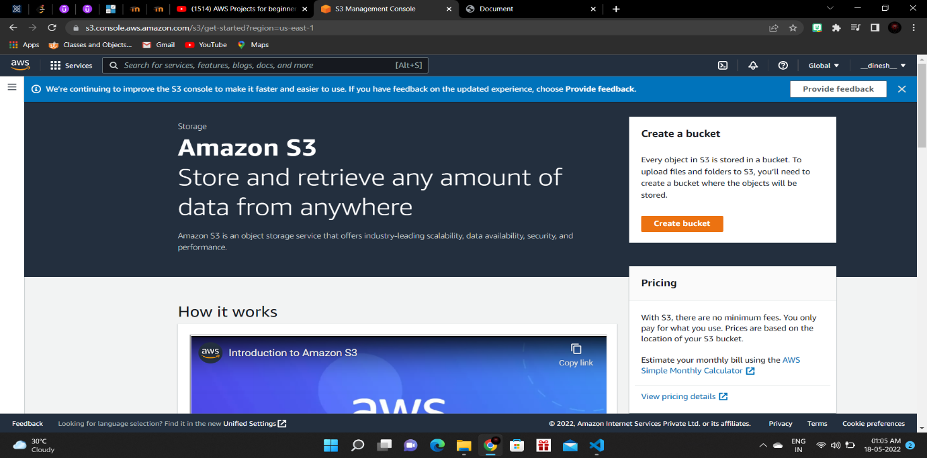

**Step 3:** Configure the new Bucket as below.

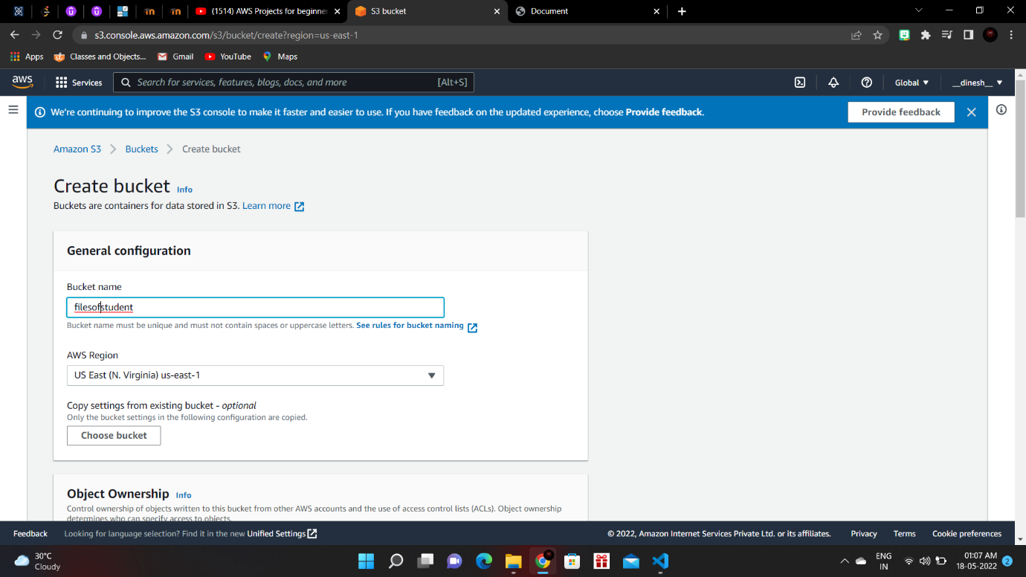

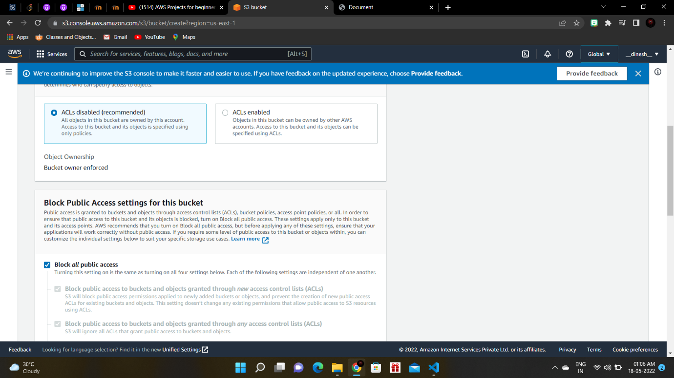

**Step 4:** The bucket will be created and is shown in the S3 dashboard.

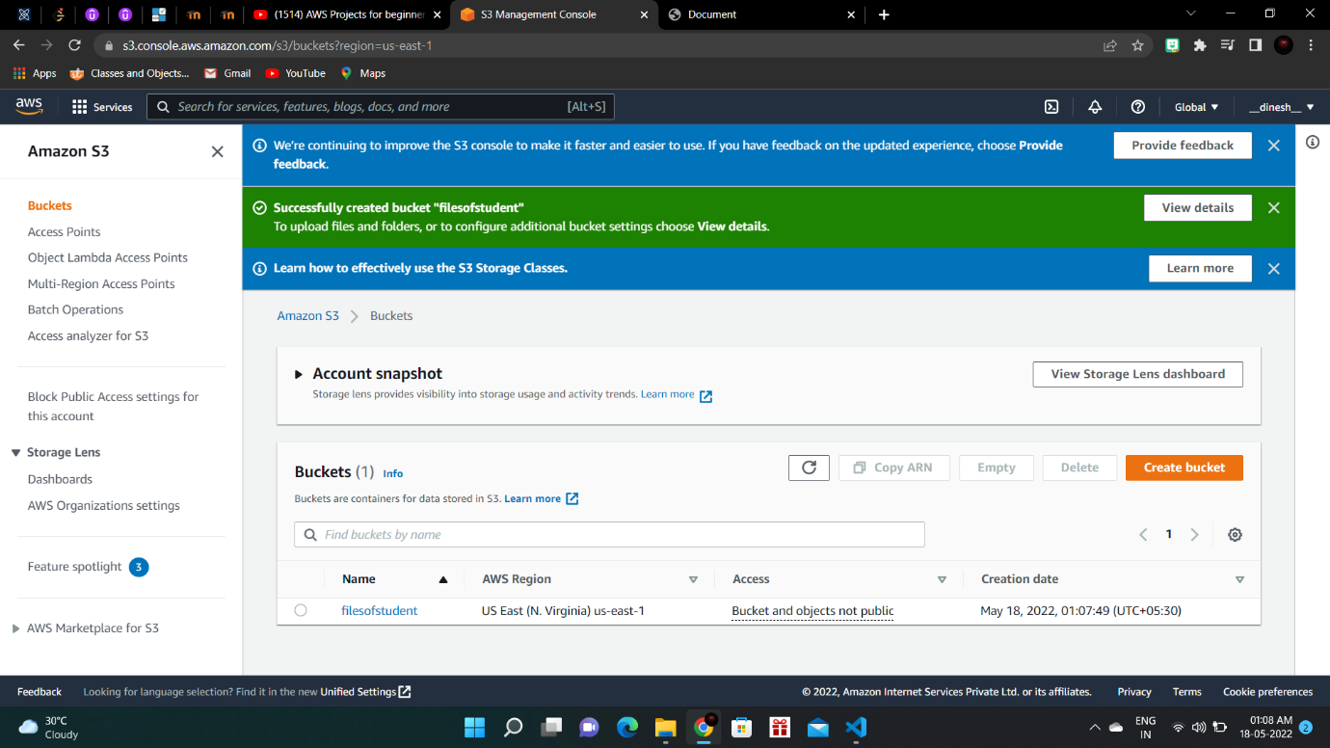

**Program Codes:**

**Index.js:**

require("dotenv/config");

const express = require("express");

const app = express();

const path = require("path");

const methodOverride = require("method-override");

const multer = require("multer");

const mongoose = require("mongoose");

const Student = require("./models/Student");

const AWS = require("aws-sdk");

const {v4: uuidv4} = require("uuid");

AWS_ID = "";

AWS_SECRET = "";

AWS_BUCKET_NAME = "filesofstudent";

const s3 = new AWS.S3({

accessKeyId: AWS_ID,

secretAccessKey: AWS_SECRET

})

const storage = multer.memoryStorage({

destination: function(req, file, callback) {

callback(null, "");

}

})

const upload = multer({storage}).single("image");

mongoose.connect('mongodb://localhost:27017/student', { useNewUrlParser: true, useUnifiedTopology: true })

.then(() => {

console.log("CONNECTION OPEN!!");

}).catch((err) => {

console.log("Error!");

console.log(err);

})

app.use(express.static("public"));

app.use(express.urlencoded({ extended: true }));

app.use(express.json());

app.use(methodOverride('_method'));

app.set('view engine', 'ejs');

app.set("views", path.join(__dirname, "/views"));

app.get("/", (req, res) => {

res.render("main.ejs");

})

app.post("/submitImage", upload, (req, res) => {

console.log(req.file);

let myImage = req.file.originalname.split(".");

const fileType = myImage[myImage.length - 1];

const params = {

Bucket: AWS_BUCKET_NAME,

Key: `${uuidv4()}.${fileType}`,

Body: req.file.buffer

}

s3.upload(params, (error, data) => {

if (error) {

res.status(500).send(error)

}

res.send(data);

})

})

app.post("/submit", async(req, res) => {

const name = req.body.name;

const registerNumber = req.body.registerNumber;

const rollNumber = req.body.rollNumber;

const file = req.body.uploadFile;

const studentDetails = {name, registerNumber, rollNumber};

const newStudent = new Student(studentDetails);

await newStudent.save();

console.log(name);

console.log(registerNumber);

console.log(rollNumber);

console.log(file);

res.redirect("/");

})

app.listen(3000, () => {

console.log("Listening on port 3000!");

})

**Student.js:**

const mongoose = require("mongoose");

const studentSchema = new mongoose.Schema({

name: {

type: String,

required: true

},

registerNumber: {

type: String,

required: true

},

rollNumber: {

type: String,

required: true

}

})

const Student = mongoose.model("Student", studentSchema);

module.exports = Student;

**main.ejs:**

<!DOCTYPE html>

<html lang="en">

<head>

<meta charset="UTF-8">

<meta http-equiv="X-UA-Compatible" content="IE=edge">

<meta name="viewport" content="width=device-width, initial-scale=1.0">

<title>Document</title>

</head>

<body>

<h1>Enter Your Details: </h1>

<br><br>

<form action="http://localhost:3000/submit" method="post">

<label for="name">Enter your Name: </label>

<input type="text" id="name" placeholder="name" name="name"><br>

<label for="regNo">Enter your register number: </label>

<input type="text" id="regNo" placeholder="register number" name="registerNumber"><br>

<label for="rollNumber">Enter your roll number: </label>

<input type="text" id="rollNumber" placeholder="Roll Number" name="rollNumber"><br>

<input type="submit" value="Submit">

</form>

</body>

</html>

**Output Screenshots:**

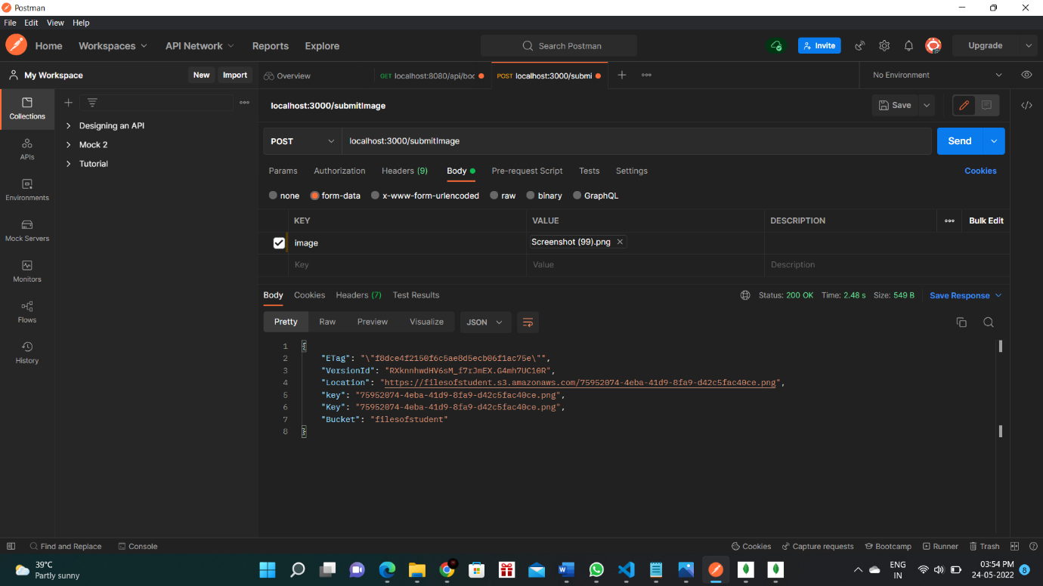

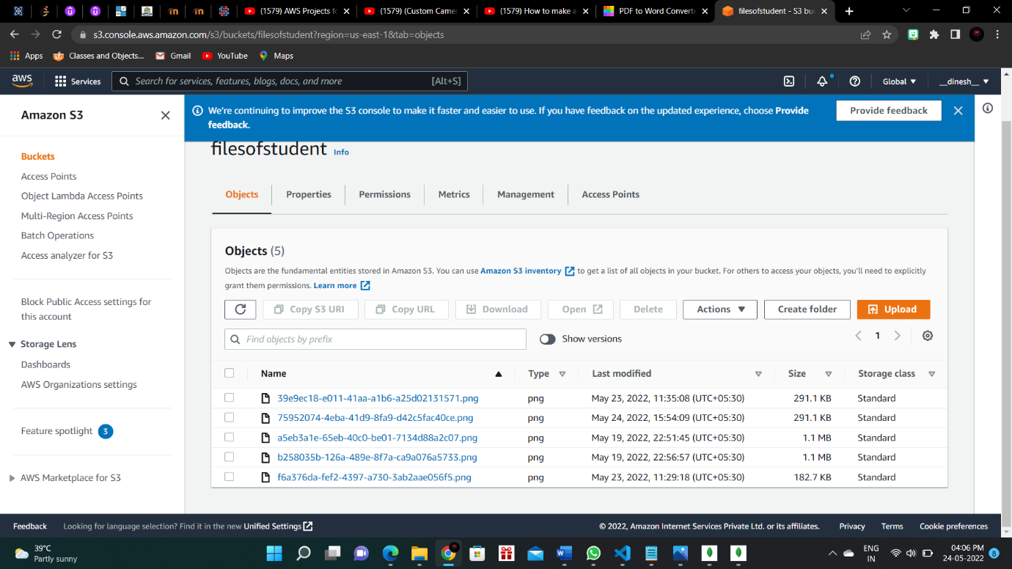

**Result:**

Thus, Storage as a Service has been successfully enabled to the nodejs application using AWS S3 services.